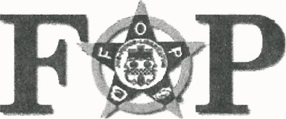
SHELBY COUNTY METRO LODGE #35
George Cave Shayne Tarena
President Secretary
OBLIGATION OF OATH
I,______________________________________ in the presence of the Creator of the Universe, and the members of the Fraternal Order of Police here assembled, do
most solemnly and sincerely promise and swear, that I will to the best of my
ability, comply with all the laws and rules of this Order; that I will recognize the
authority of my legally elected officers, and obey all orders there from not in
conflict with my religious or political views, or my rights as an American citizen;
that I will not cheat, wrong or defraud this Order, or any member thereof, or permit
the same to be done if in my power to prevent it; that I will at all times aid and
assist a worthy brother or sister in sickness or distress, so far as it lies in my power
to do so; that I will not divulge any of the secrets of this Order to anyone not
entitled to receive them. To all of which I most solemnly and sincerely promise
and swear. Should I violate this, my solemn oath or obligation, I hereby consent to
be expelled from the Order.
Your membership becomes effective when the State Lodge receives your dues.

Check number______________ Cash $_______________

Signed______________________________________________ Date_____________
Witness_____________________________________________ Date_____________
E-Mail ________________________________________

